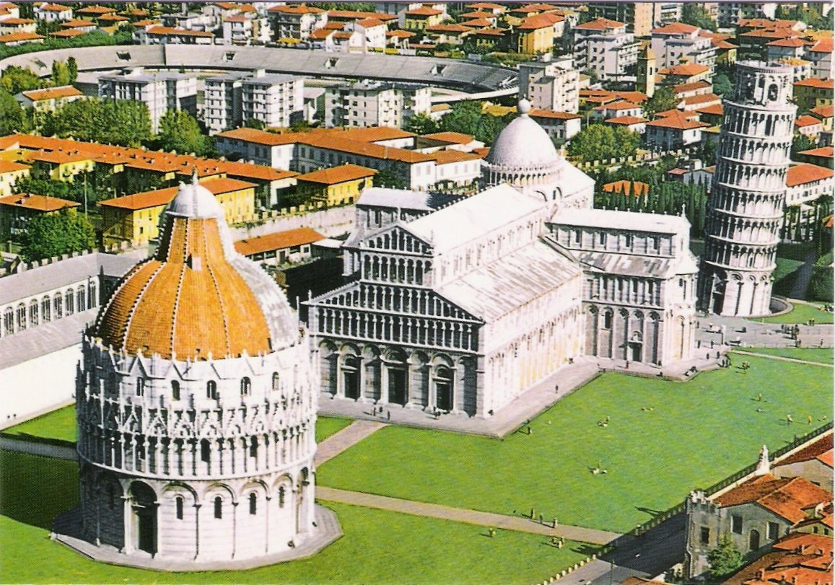
Enjoy also: “Luminara di San Ranieri”, Pisa 16 June 2015
Square of Miracles, Pisa

PRECONFERENCE WORKSHOP OF FOOD TECHNOLOGY 2015 CONFERENCE
“FRONTIERS IN FOOD SCIENCE FOR FEEDING THE WORLD”
Department of Agriculture, Food and Environment (DAFE), 15 June, PISA, ITALY
FIRST ANNOUNCEMENT

Dear colleagues, dear students,
University of Pisa and Department of Agriculture, Food and Environment organizes a pre-conference workshop of Food Technology-2015 Conference organized by OMICS International which will be held from 10-12 August 2015 in London.
We cordially invite you to participate with oral presentation or poster at the preconference workshop which will take place in Pisa, a very beautiful town in Tuscany (Italy). This is a very good opportunity to meet together food technology science and industry.
Major topics:
"FOOD PROCESSING AND STORAGE TECHNOLOGIES" Chair prof. Angela Zinnai
"FOOD SAFETY AND TRACEABILITY" Chair dr. Francesca Venturi
"FOOD ECONOMY AND SUSTAINABILITY" Chair prof. Gianluca Brunori

Venue and accomodation: Department of Agriculture, Food and Environment, Pisa, Italy

Deadline for abstract submission: March 15, 2015. E-mail addresses for abstract submission: angela.zinnai@unipi.it; francesca.venturi@unipi.it. Along with abstracts the authors should also send

Registration form (given below). Working language will be English.

Registration fee is 150 USD per each participant and includes: book of abstract, attendance of the all workshop sessions, lunch and refreshment. The account for registration payment will be given in the second announcement. Instruction for abstract preparing are given below.

Preconference workshop attendee who will be interested to attend Food Technology-2015 Conference (http://foodtechnology.conferenceseries.com) will get 30 percent waiver on registration fee. OMICS will supply certificates for attendance the workshop. Selected papers will be published in journals indexed in international databases. Supporting journal is AGROCHIMICA, edited by Pisa University Press.

Regional Organizing Committee members:
Prof. Andrich Gianpaolo
Prof. Brunori Gianluca
Dr.ssa Mariano Elide
Dr. Quartacci Mike
Dr.ssa Venturi Francesca*
Dr.ssa Zappa Giovanna
Prof.ssa Zinnai Angela*
*Members of Organizing Committee for Food Technology 2015 (London, 10-12 August 2015)
REGISTRATION FORM

Personal data:
First name | Last name | Title
Affiliation:
Mailing address:
Postal code: | City: | Country:
Phone: | Fax: | E-mail:

Paper submission:
Title of Paper:
Author(s)
Preferred type of presentation (oral or poster):

Date of registration for workshop participation: ____________________

Participants are requested to submit the completed Registration form to the e-mail:
angela.zinnai@unipi.it; francesca.venturi@unipi.it

IMPORTANT DATES

Abstract Submission Deadline: March 31, 2015
Registration Fee Payment deadline: May 15, 2015

Title: XXXXXX

Author(s): Name, initials of surname; XXX
Abstract text: max 250 words

Biography of the author presenting the research:
max 100 words

FOTO
of the author presenting the research

